Croft Parish Council 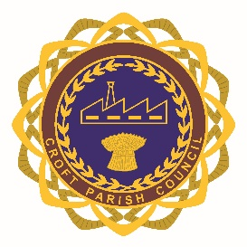
The Proclamation
Whereas it has pleased Almighty God to call to His Mercy our late Sovereign Lady Queen Elizabeth the Second of Blessed and Glorious Memory, by whose Decease the Crown of the United Kingdom of Great Britain and Northern Ireland is solely and rightfully come to The Prince Charles Philip Arthur George:
We, therefore, the Lords Spiritual and Temporal of this Realm and Members of the House of Commons, together with other members of Her late Majesty’s Privy Council and representatives of the Realms and Territories, Aldermen and Citizens of London, and others, do now hereby with one voice and Consent of Tongue and Heart publish and proclaim that The Prince Charles Philip Arthur George is now, by the Death of our late Sovereign of Happy Memory, become our only lawful and rightful Liege Lord Charles the Third, by the Grace of God of the United Kingdom of Great Britain and Northern Ireland and of His other Realms and Territories, King, Head of the Commonwealth, Defender of the Faith, to whom we do acknowledge all Faith and Obedience with humble Affection; beseeching God by whom Kings and Queens do reign to bless His Majesty with long and happy Years to reign over us. Given at St. James’s Palace this tenth day of September in the year of Our Lord twenty thousand and twenty-two.
GOD SAVE THE KING

