Our ref: M62 J10-12SMP/002  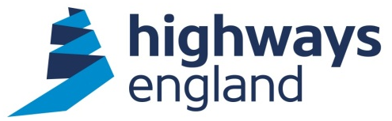 | Malcolm Carter  Highways England  Barton Hall Industrial Estate  Hardy Street  Manchester M30 7NB  7 August 2018
Dear Stakeholder,

M62 Junctions 10-12 Smart Motorway Project works update

I am contacting you further to the email we sent to you in early July, announcing a number of new smart motorway schemes in the North West.

With the Manchester smart motorway (M60 junction 8 to M62 junction 20) now fully operational, work will begin on the M62 junction 10 (Croft) and junction 12 (Eccles) from Saturday 11 August 2018.

As our region continues to see rapid growth, Highways England is committed to ensuring our roads have the capacity to support it. This scheme is one of four new smart motorway schemes, worth around £500 million, which will all begin construction within the next 18 months.

What is a smart motorway?

Smart motorways use the latest technology to monitor traffic levels so that variable speed limits can be automatically changed on overhead electronic signs to keep traffic moving at a steady speed. The hard shoulder on this smart motorway route will be converted into a permanent extra lane and 11 new emergency areas will be created for drivers to use if they break down.

New CCTV cameras will also provide 100% coverage of the route and Highways England will be able to display red Xs on overhead signs to close any lane, allowing its traffic officers and the emergency services to get through.

What will construction of the M62 J10-12 scheme mean for customers?

Temporary narrow lanes will be introduced on a 3-mile stretch of the M62 near junction 12 to allow us to work at the side of the motorway, and a 50mph speed limit will be needed for the safety of drivers and workers. The roadworks will be gradually extended to junction 10 by the autumn and the smart motorway scheme is due to be completed by spring 2020.

In order to put the narrow lanes out on the highway, we will initially need to close the road overnight for a period of 10 days. Full closures will start on 11 August at 10pm and will be needed nightly (10pm-6am) up until 6am on 22 August. However, there will be no closure on 18 August. These closures will take place at night to minimise disruption and will have no impact on drivers during the day.

During the full closures, the following diversion route will be operating:

M62 eastbound – M6, M56, A5103 Princess Parkway and M60.
M62 westbound – same as above in reverse.

Find out more and contact us

In the meantime, if you have any questions or would like to know about this work, please contact me at M62J10-12SmartMotorway@highwaysengland.co.uk or call us on 0300 123 5000. You can also visit our website at www.highwaysengland.co.uk/m62j10to12

Malcolm Carter
Project Manager, Highways England

